GRADE 7 ACCELERATED · UNIT 2 · LESSON 6
Plotting, Ordering and Comparing Real Numbers
Circuit 7A.02.06 ANSWER KEY

Work the four parts in order, on your own. Everything here is from Lessons 1 through 5. This is the last practice before the unit assessment.
PART 1. Comparing
Use <, > or =. One of the six is an equality.
1. | 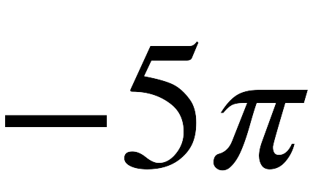 | < | 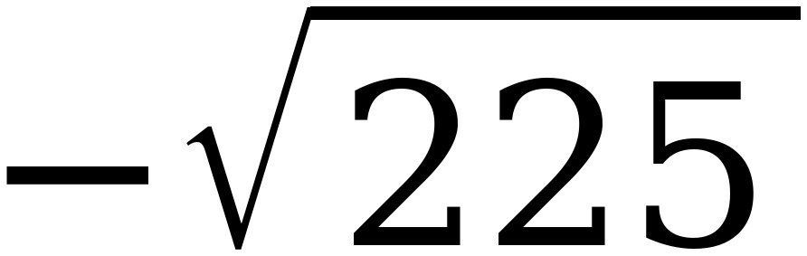
2. | 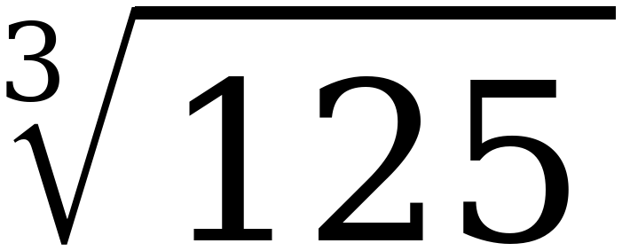 | = | 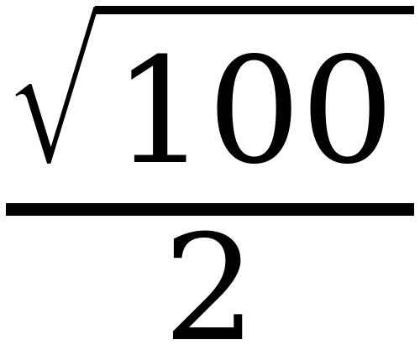
3. | 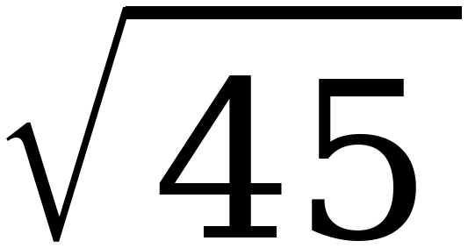 | < | 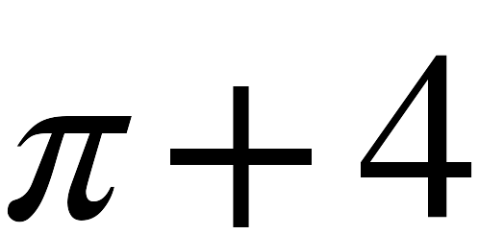
4. | −7 | < | 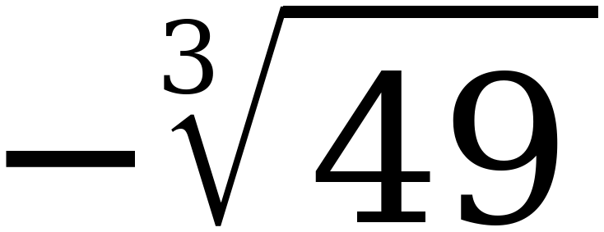
5. | 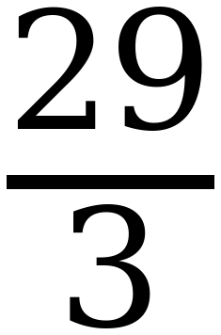 | > | 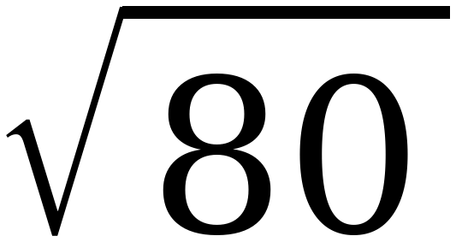
6. | 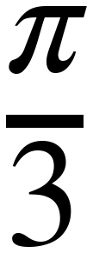 | < | 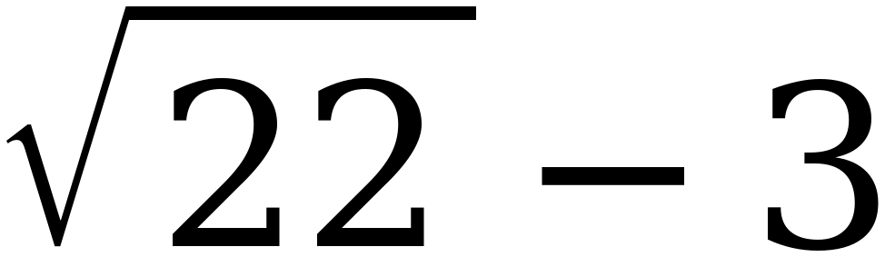

Values: −15.708 vs −15; 5 vs 5; 6.708 vs 7.142; −7 vs −3.659; 9.667 vs 8.944; 1.047 vs 1.690. Row 4 is the one to watch — −∛49 is about −3.7, which is well to the right of −7. Row 2 is the equality and a student who never writes = has not checked it.
PART 2. Sorting and plotting
A number is irrational only if it cannot be written as a ratio of two integers.
7. Sort the five expressions, then plot and label each one on the number line.
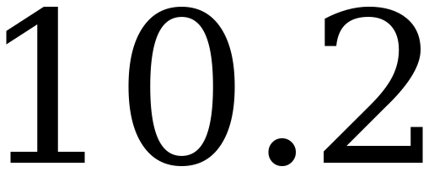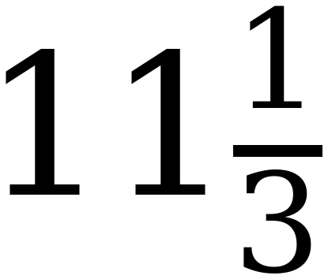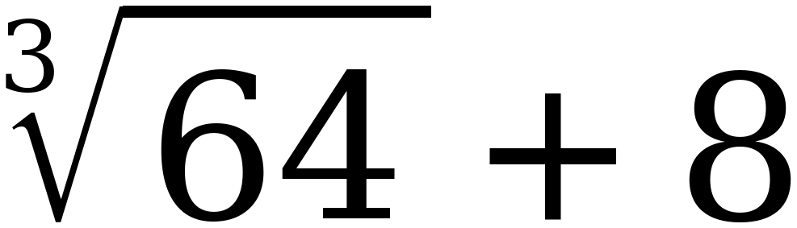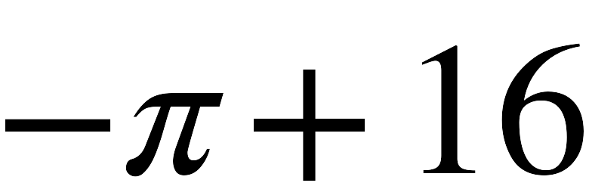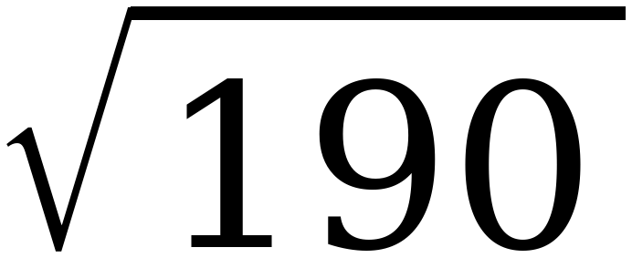
Only rational numbers | Includes an irrational number
 | 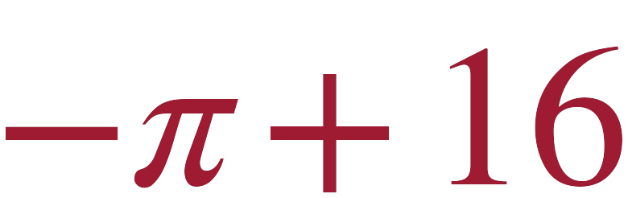
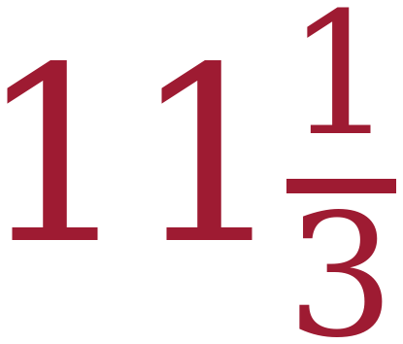 | 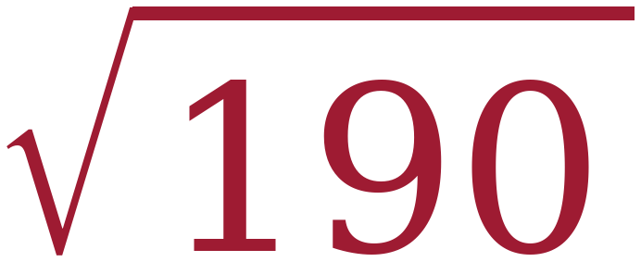
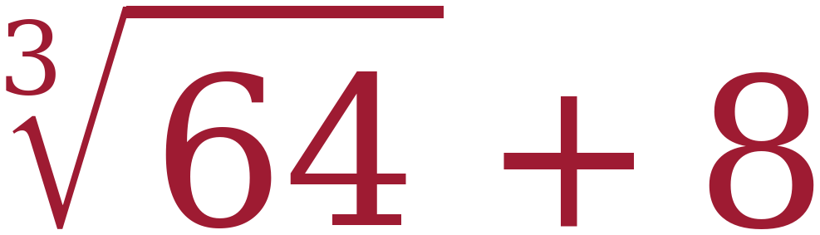

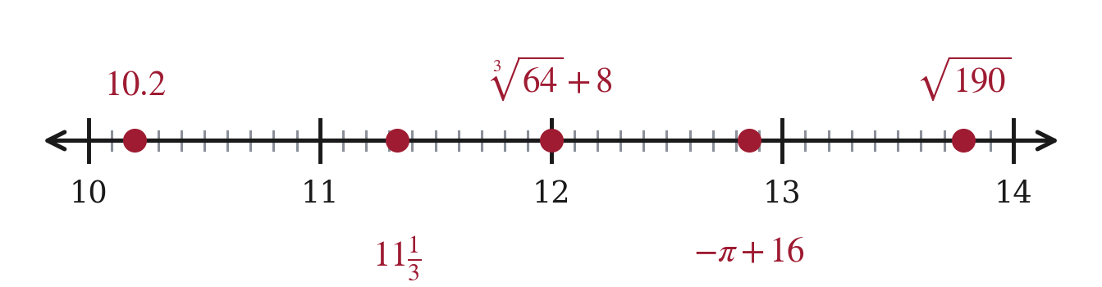
∛64 + 8 = 4 + 8 = 12 exactly, so it is rational. Values: 10.2; 11.333; 12; 12.858; 13.784.
8. Plot and label each expression on the number line.
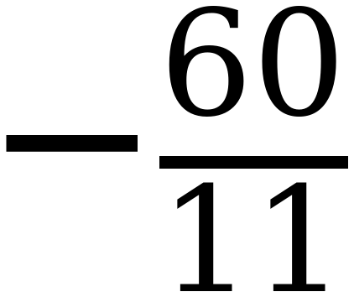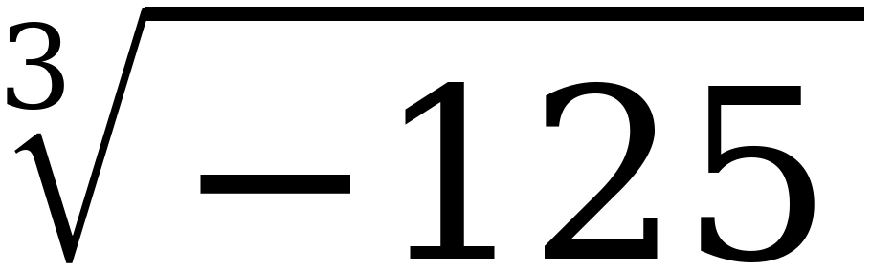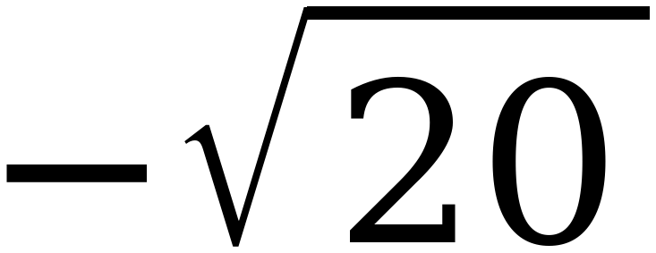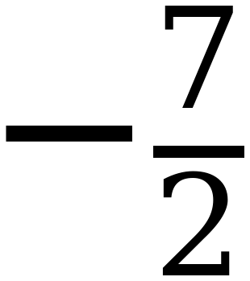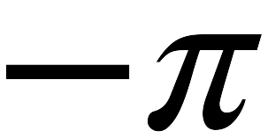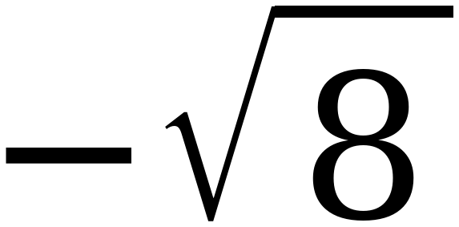
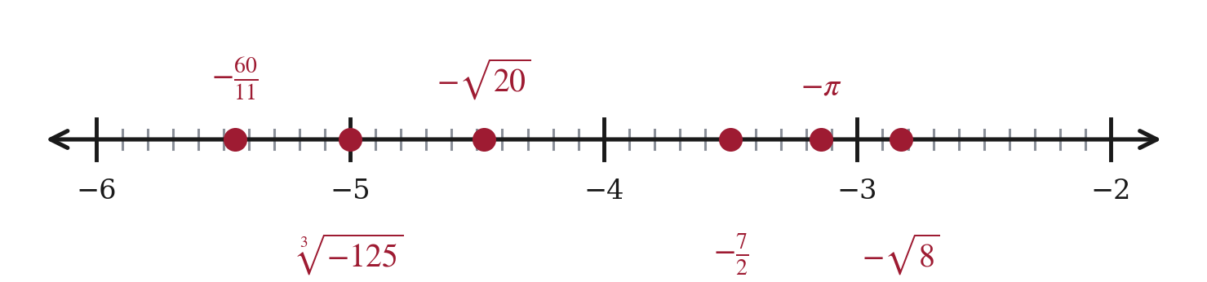
Values: −5.455; −5; −4.472; −3.5; −3.142; −2.828. All six are negative, so the one that looks biggest is furthest left.
PART 3. Error analysis
Read the work, find the error, then do it correctly.
9. Sara approximated 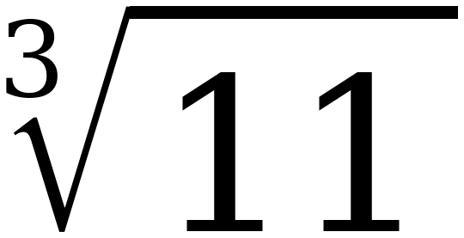 like this:
“11 is between 9 and 16, which are both perfect squares. So lies between 3 and 4, and it is closer to 3 because 11 is closer to 9 than to 16.”
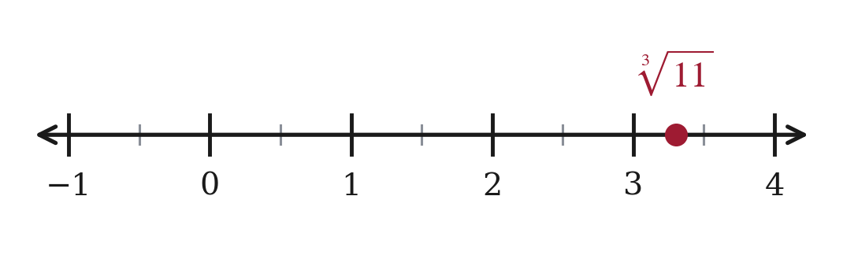
a. What is Sara's error?
She used perfect squares to estimate a cube root. She should have used perfect cubes.
b. Redo it correctly, then plot the right value.
11 lies between the perfect cubes 8 and 27, so ∛11 lies between 2 and 3.
11 − 8 = 3 and 27 − 11 = 16, so 11 is much closer to 8. ∛11 ≈ 2.2
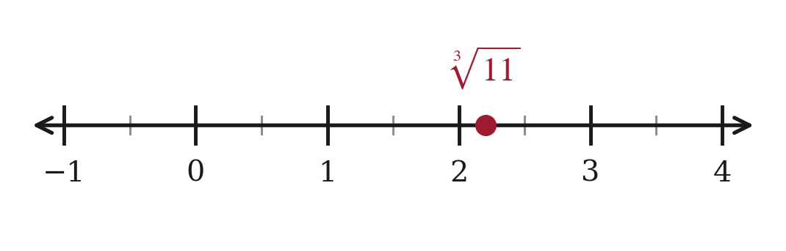
Sara's method is right and her list is wrong. Say that out loud — she is one word away from a correct answer, and the word is “cubes.”
PART 4. Ordering and plotting
10. Order the numbers from least to greatest, then plot and label each one.
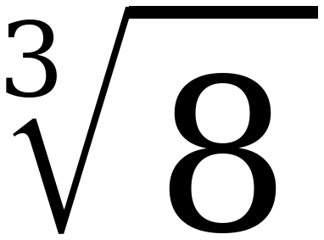 π 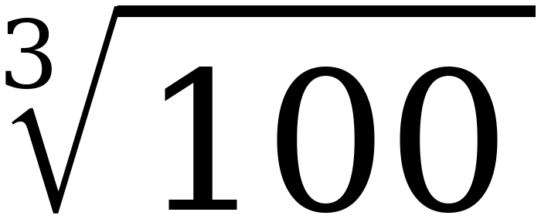 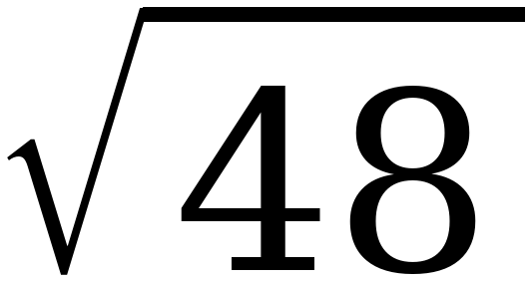 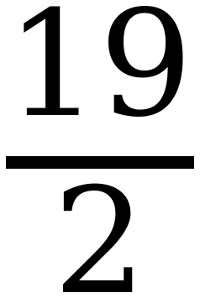 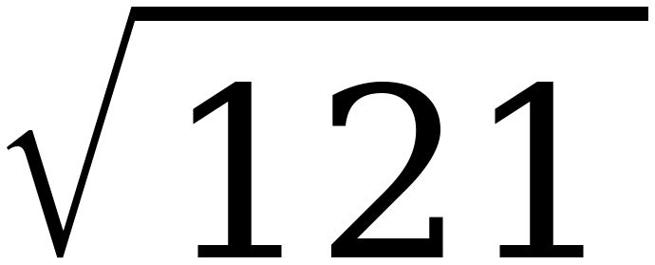
∛8 , π , ∛100 , √48 , 19/2 , √121
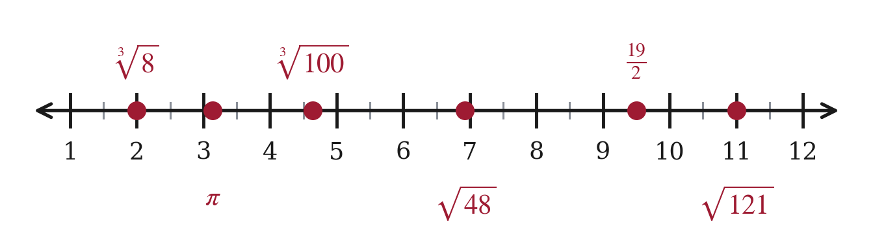
Values: 2; 3.142; 4.642; 6.928; 9.5; 11. Two of the six are whole numbers in disguise.
11. Order the numbers from least to greatest, then plot and label each one.
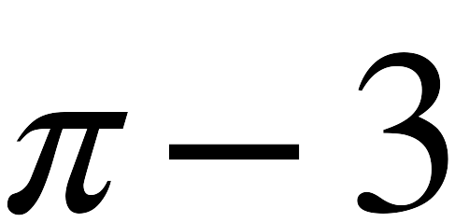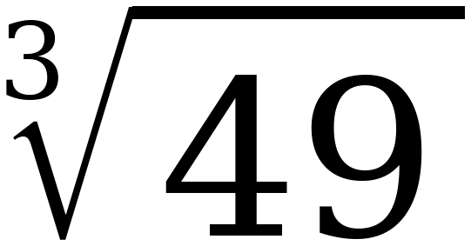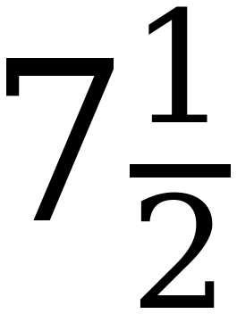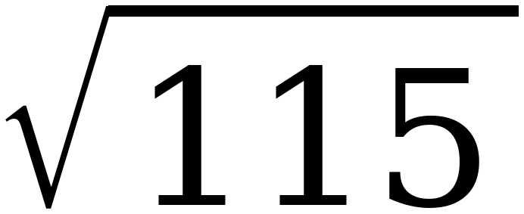
π − 3 , ∛49 , ∛125 , 7½ , √80 , √115
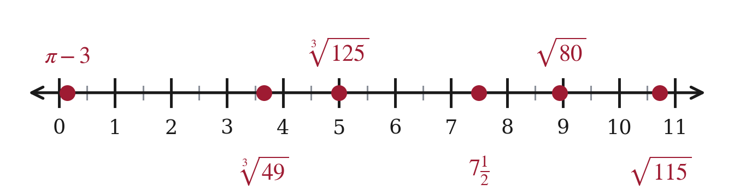
Values: 0.142; 3.659; 5; 7.5; 8.944; 10.724.
STRETCH. Beyond the range the test uses. Same method, bigger cubes.
12. Find the value of 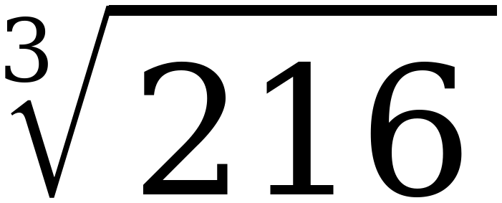 and of 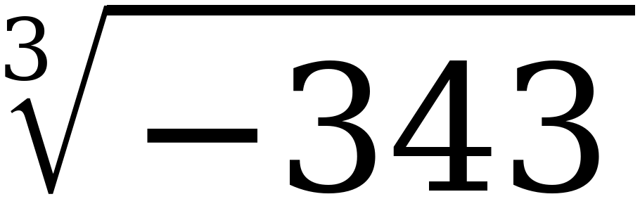.
∛216 = 6, because 6 × 6 × 6 = 216. ∛−343 = −7, because (−7)³ = −343.

